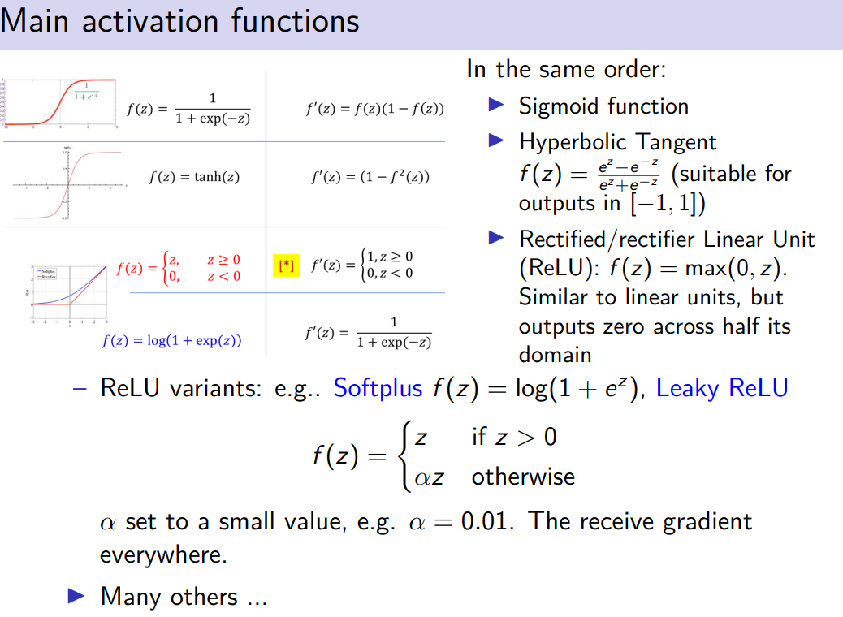

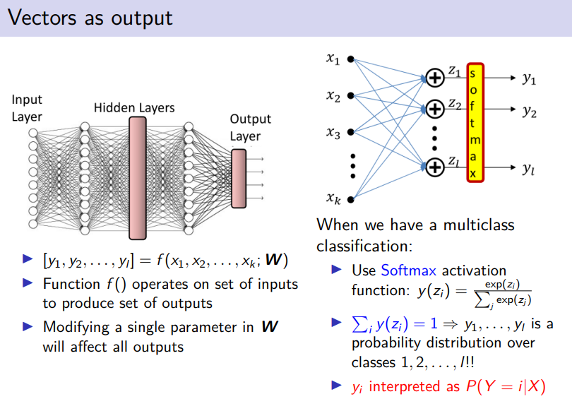

we might have multiple inputs, our network might have hidden layer and one output layer

output layer might contain one neuron or even more then one.
Your network computes the function f() that takes a vector and produce as output a vector

when we change an individual input (x3) it would change potentially all the output neurons, might change the output of any neuron

if we change the erights connecting x3 to all the oupits (z1,z2,z3) might change all the output, we are interested on the weights because we will train them

multiclass classification problem: what to do in case of a multiclass? we use softmax actiation function

if we have multiclass classification problem with c different classes we will use c output neurons, each output neuron to some extend give us a likelihood that the input can be classified for that class

first neuron = class 1
second neuron = …

softmax activation fucntiion, the output are y1, y2, … yl (l classes and l output neurons)

the value of each neuron is a value between 0 and 1. We need to undergo the activation neuron

we use the same asctivation function. exp(z) devide by the sum of the exp(z) of all the others neurons,.

we get a probability distribution. favorable cases and divided by total cases

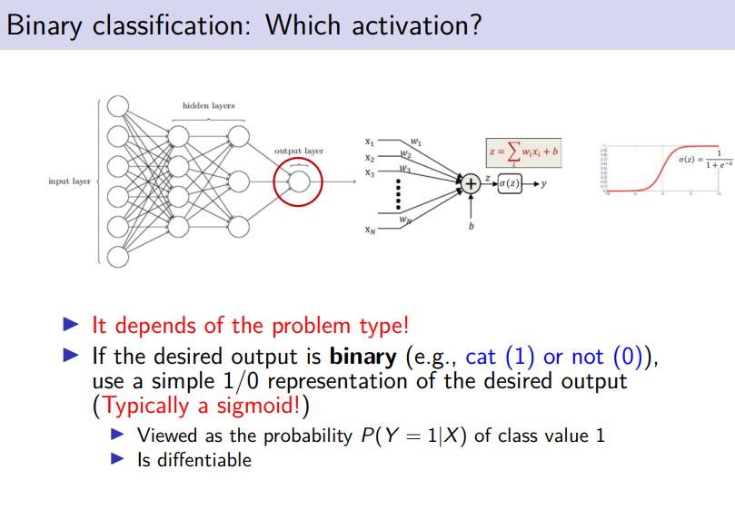
what if we have a binary classification.

use sigmoid activation function.

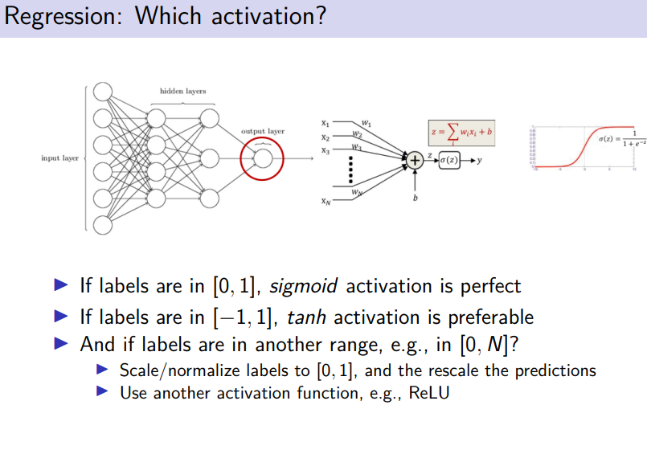

Activation Functions : Sigmoid, tanh, ReLU, Leaky ReLU, PReLU, ELU, Threshold ReLU and Softmax basics for Neural Networks and Deep Learning | by Himanshu S

dominio arctan (-π /2 , + π /2)
dominio tanh (-1, +1)

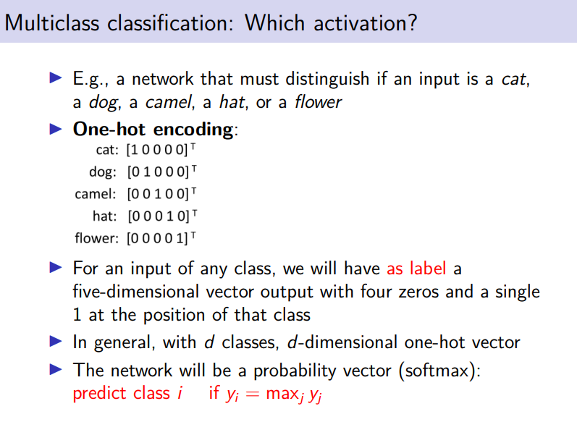

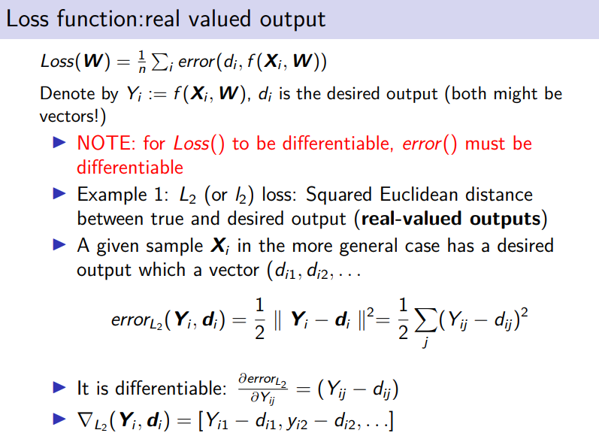

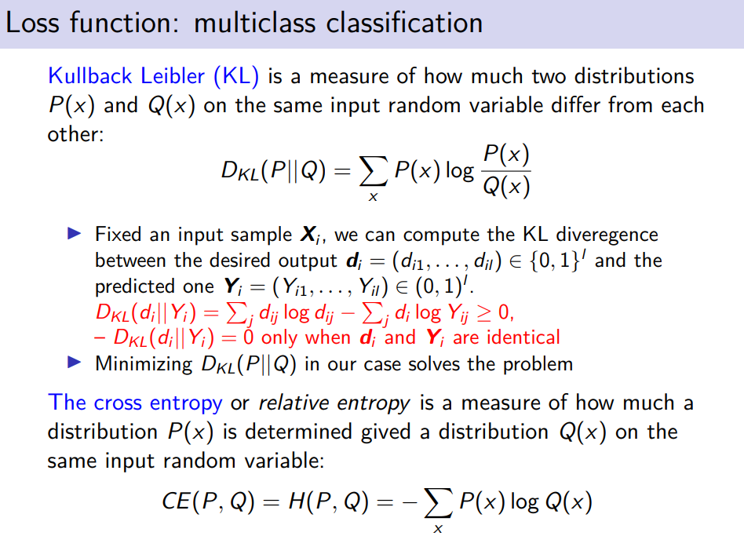

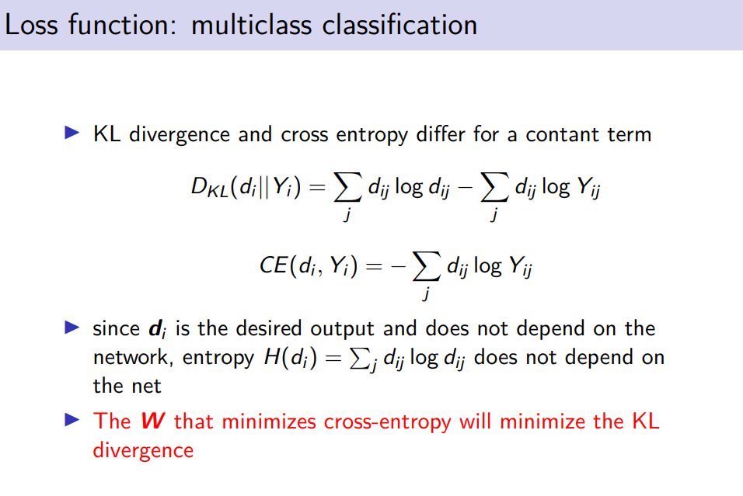

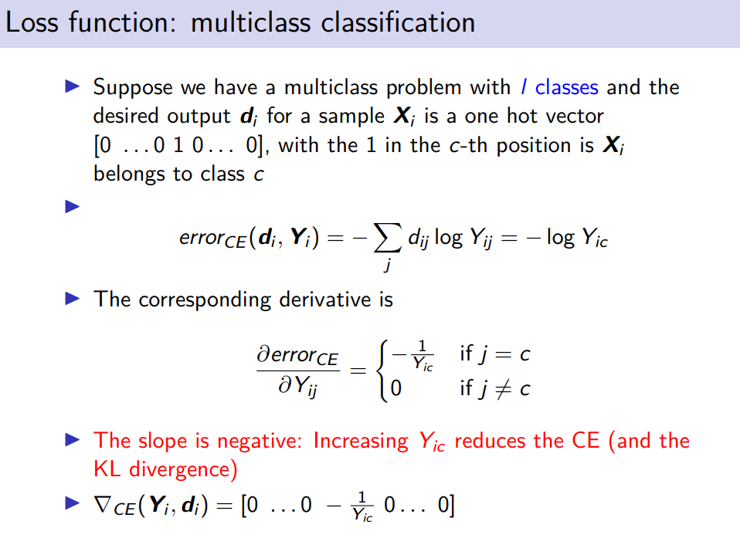

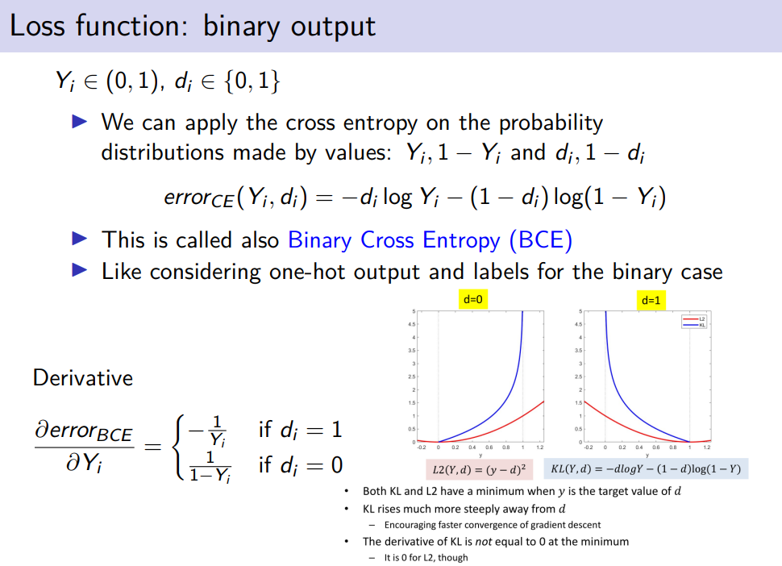

cross entropy with binary classification problem

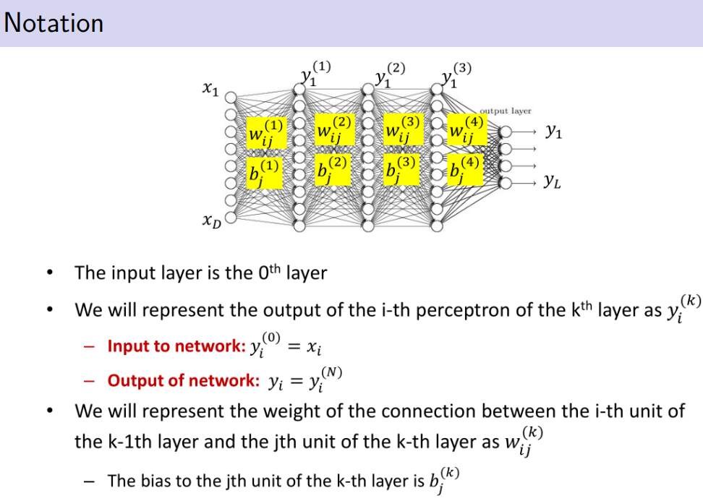

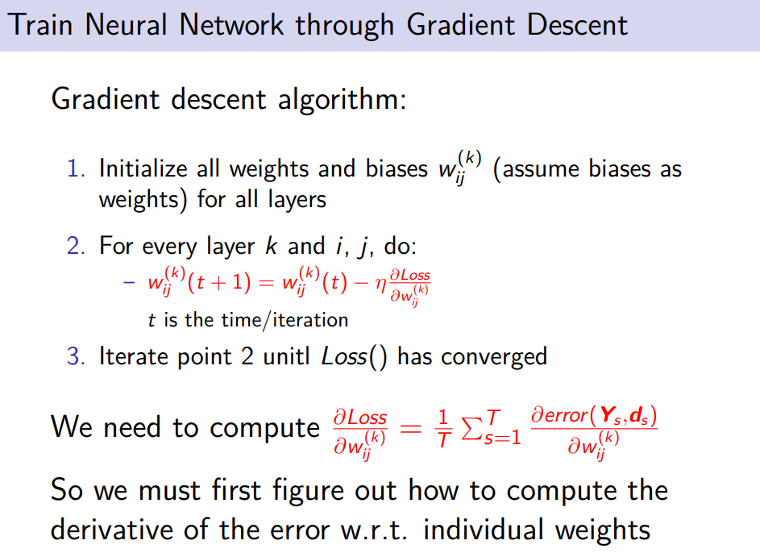

we need to initizialize each initial weights and biases

different starting point are possible.
Then step 2
for any input unit i, and output unit j update the corresponding weights.
repeat these steps iteratively, we can perform the update, cosineserng time t.

how to update weights? take previous weights, subtract the scaled version of the gradient of the loss and derivative of the loss function with respect to that weights

to compute the gradient of the loss we need toc compute the gradient of the error compared to the weight

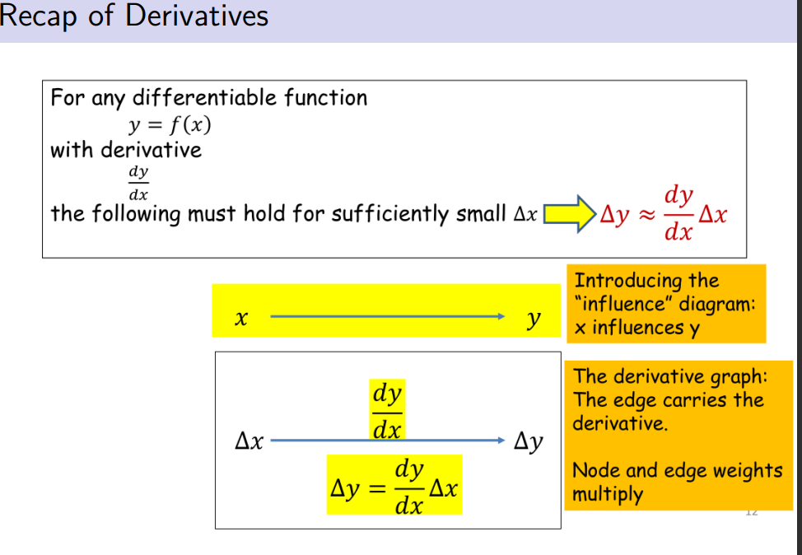

when I have a function f(x) the derivative is almost how much my output y wokukd change in corresponding in the changing input

We have edges that correspodng to the derivatives, nodes and edges are multiplied. In order to get Δy I have to multiply Δx by dy/dx

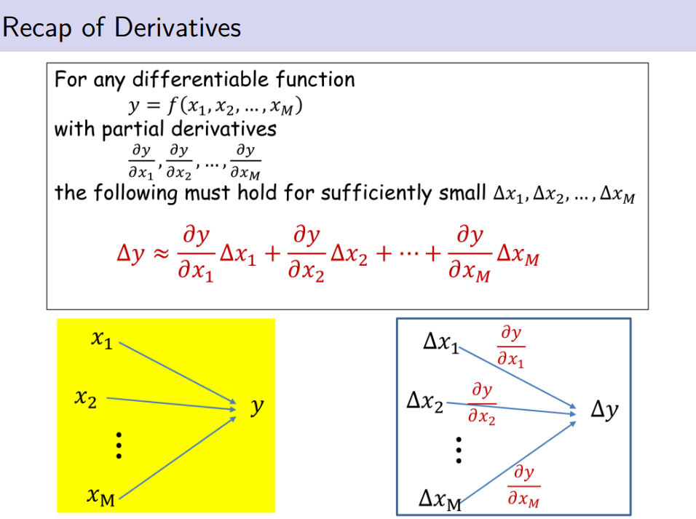

Δy depends on some terms, each of them is exactly the variation that I get in eahc individual component.

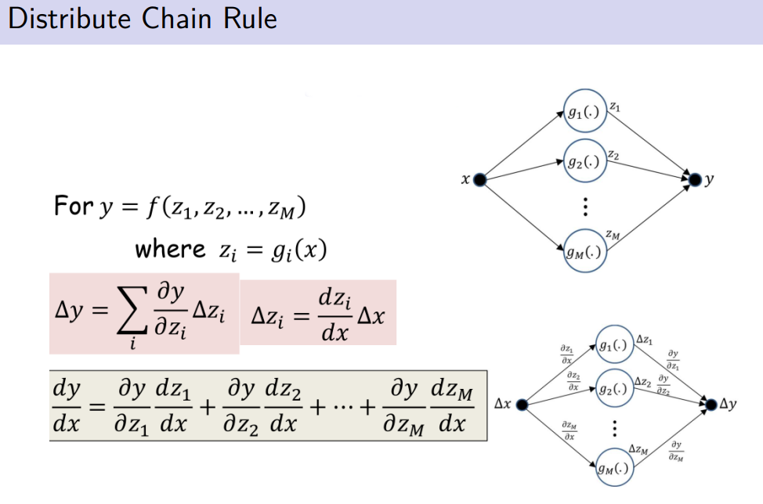

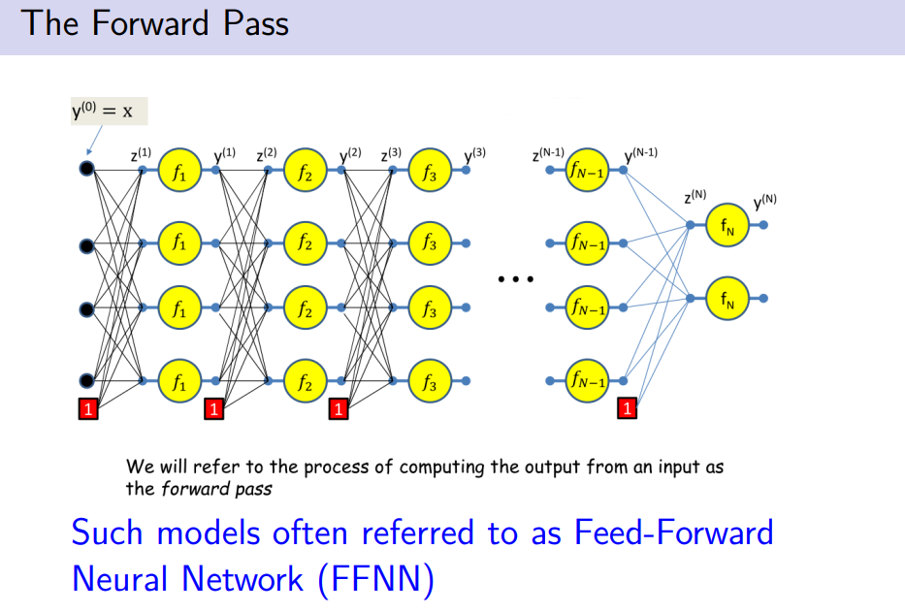

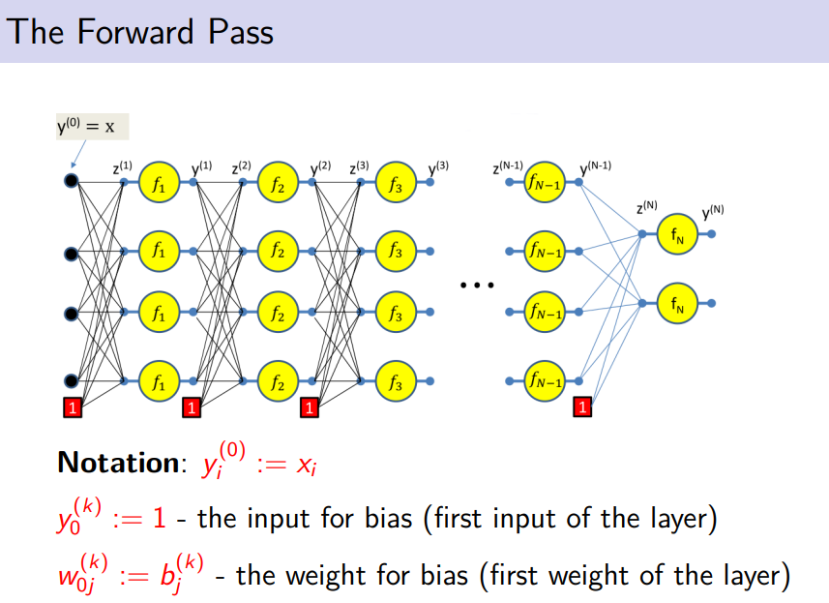
notation

all biases are related to the first input

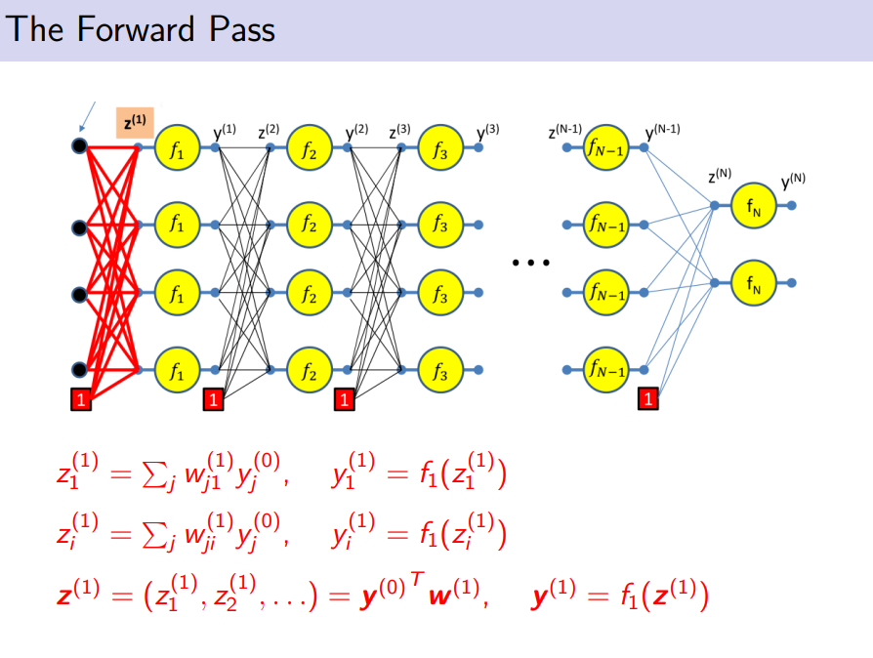
applay the activation function that is the same for each layer

the activation function for each layer might be the same or different

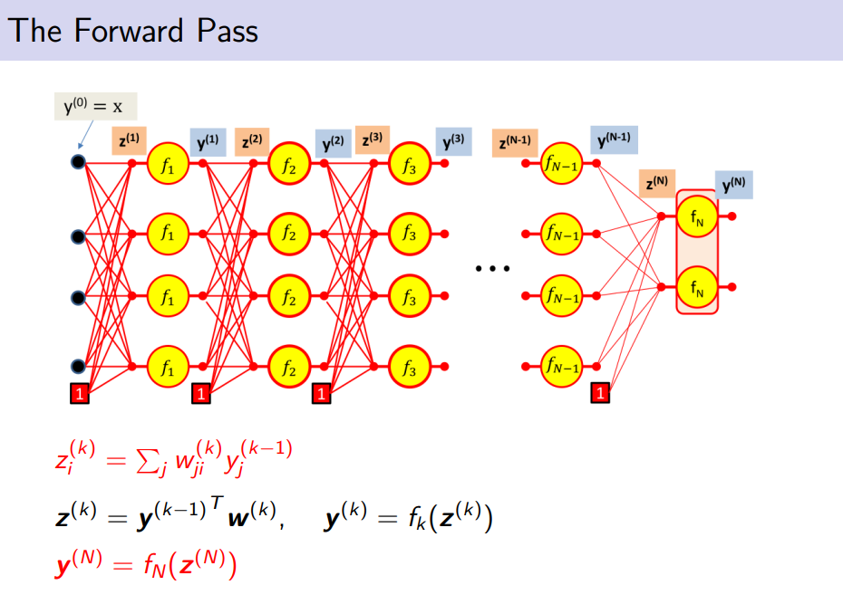
the output y^{k} is the f_{k} applied to z^{k}

which is the outcome of the network
y^{N} is the activation function applied to the z^{n}

we have the output of the network

we can not run layer k if we did not run layer k-1

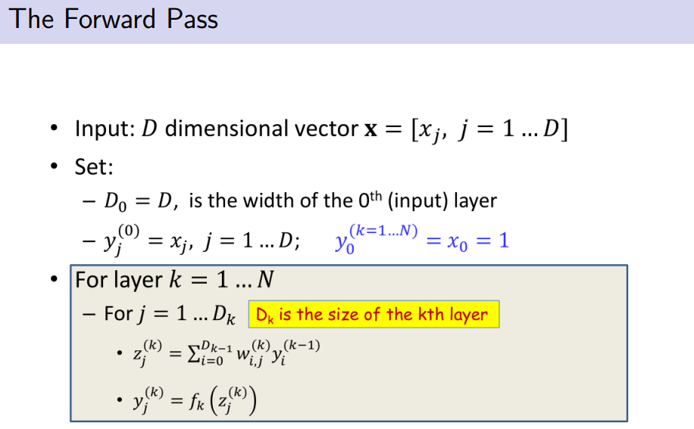

d_{k} numb3r of hidden units in each layer

in order to compute the forward passing we just eitherate for any layer in order
and for any unit j just computed z_{j} for layer k
